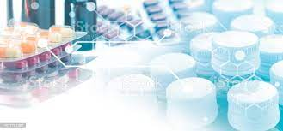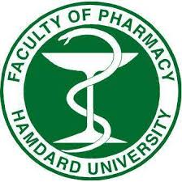FACULTY OF PHARMACY

Lab Manual

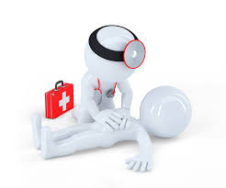clinical pharmacy

**CLASS: PHARM-D 4th PROFESSIONAL (morning)**

**7th SEMESTER**

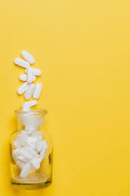**CODE: PHARM-605**

**group members:**

1. 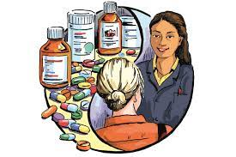**alvina ahmed:** (R-11) CMS: 62-2019
2. **filza saeed:** (R-26) CMS: 49-2019
3. **hasan raza azmi:** (R-54) CMS: 95-2019
4. **m.kashan malik:** (R-57) CMS: 84-2019
5. **sadia sheikh:** (R-101) CMS: 280-2019

**submitted to: mr.arshad yaqoob**